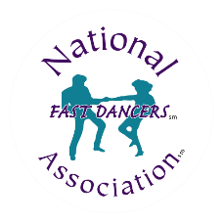

NATIONAL FASTDANCERS ASSOCIATION CLUB MEMBERSHIP APPLICATION
Bop *Carolina/Collegiate Shag *East Coast/West Coast Swing *Jitterbug *Hand Dance *Push/Whip *Lindy Hop *Jazz *Zouk Blues/Soul *Line Dance *Balboa *Ballroom *Latin/Rhythm *Country Western *Acro *Fitness *Disco *Tap *Fusion

2026 ANNUAL NEW/RENEWING
Dues: 30 cents per member | Minimum fee: $25 - Maximum fee: $100

New Membership or Renewal? Please circle one

Club name:
Contact name:
Address:
Phone: Email:
Website:
Please circle any info. that you DO NOT want published on our website or newsletter

Number of members: Amount due:

How did you hear about the NFA?
Have you been contacted by any of the PRO’s (ASCAP, BMI, SESAC)? If yes, which PRO and what is the name of the representative who contacted you? (We will inform them that you joined the NFA)

Signature: ___________________________________________________________ Date: ___________________

Complete and mail with a check made payable to:
National Fastdancers Association
9370 River Pine Rd, Jacksonville, FL 32257

Tel: 877-632-2582 • Secondary: 844-632-3278 • Email: chris@fastdancers.com
Website: www.fastdancers.com

